**Test Automation – Assignment III**

**Application to be tested - URL:**

https://www.myntra.com

**Tasks:**

* Go to myntra.com

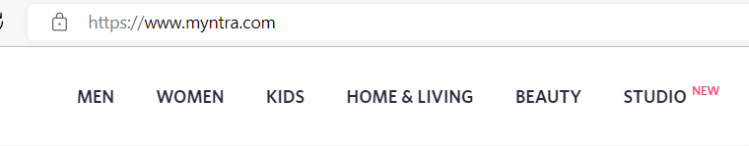

* Enter “Bluetooth headphones” in searchbox 
* Click Search button
* Select “whats new”

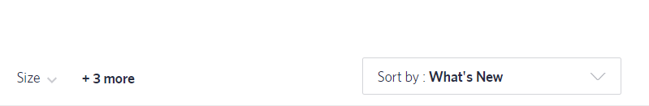

Select brand as JBL

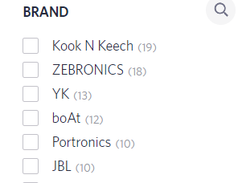

Validate if the item displayed at the top has brand name as JBL in it.

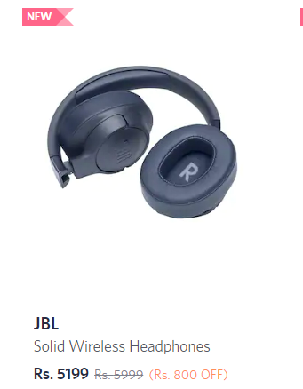

**Refer screenshot for each step**